Assignment 19/11/2020

Name – Archisman Roy

CSE 2nd year 3rd sem

Roll - 50

1) Write a program in Python to append list of five players in a list and print it using append.

2) Write a program in Python which counts frequency of numbers from a list using count.

3) Write a program in Python to sort list using sort.

4) Write a program in Python to search for an item from a list using index.

5) Create a table using list of lists by writing a program in Python.

Hint: table1 = [ [ 1, 2, 3 ], [ 4, 5, 6 ] ]

6) Write a program in Python to store two lists and compare them.

Outputs –

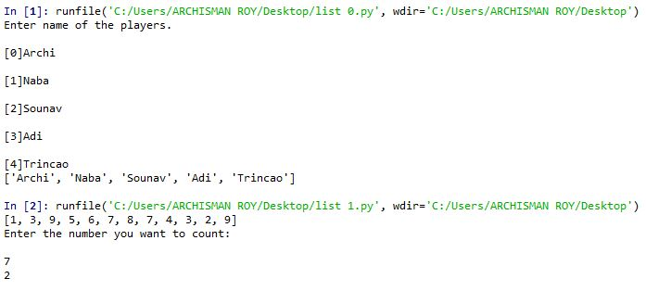

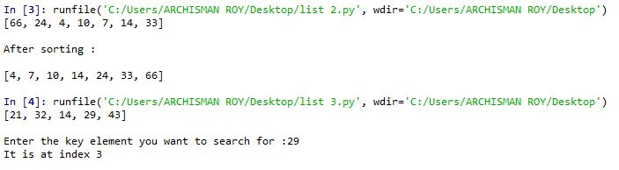

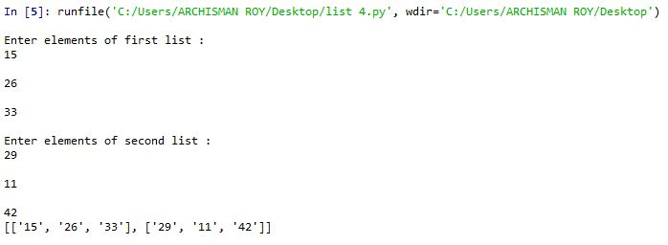

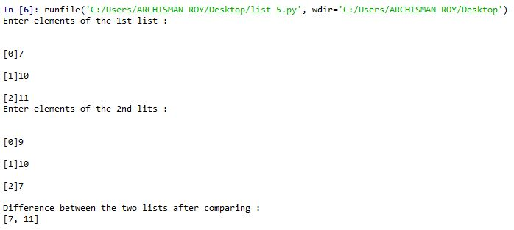

Questionnaires:

1. Why lists are called mutable?

Ans. Unlike strings, lists are mutable. This means we can change an item in a list by accessing it directly as part of the assignment statement. Using the indexing operator on the left side of an assignment, we can update one of the list items.

1. What are the advantages of using list compared to array in C?

Ans. Lists in python are better than C as they are mutable and we can bring any change at any time.

A lot of functions are applicable like delete, append, pop etc.

Python will allocate a few extra elements when all allocated elements get used. This means that appending items to lists is faster.

List are flexible and can be heterogeneous.

Arrays you must store primitives of the same type, whereas lists can store anything.